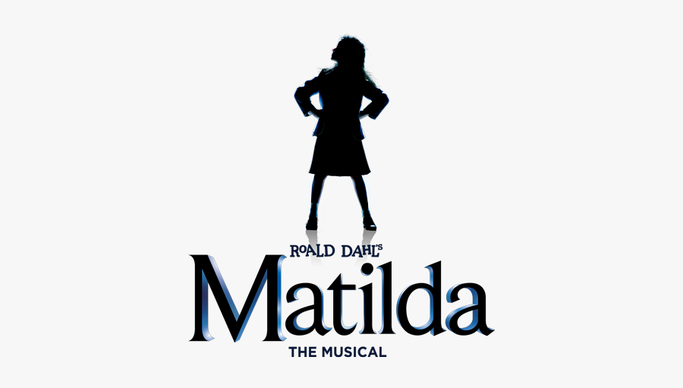
Thanks to everyone who has already completed and submitted their audition registration. We are looking forward to hearing and seeing what you have been working on. For those of you who have not yet signed up to audition please submit your registration by 12pm on June 20th. We will not be accepting entries past this deadline.

Those who have received approval to send in a video audition will be required to submit their recorded entry by 12pm on June 23rd.
We ask that all auditionees arrive 30 - 45 mins prior to their start time in order to: sign in, submit their headshot, and warm up. As a reminder, the auditions will take place at Adagé Studio located at 540 Cairnsmore Street, Duncan.

The start time for each section will be as follows:
SATURDAY, JUNE 24
11AM - All auditionees for Matilda, Bruce, and Little Kids/Big Kids.
3PM - All auditionees for parents and adult roles.

Auditions for named roles will take place privately in front of the Directorial Team and the Little Kids/Big Kids plus Parents will be seen as a group. Please keep in mind that if you have signed up for multiple roles you will need to stay for that role’s section of auditions to be called.

All auditionees that are required for call-backs will be contacted later the same evening. Please arrive 30 mins prior to the start time prepared to read as a group for this section of the audition process.

SUNDAY, JUNE 25 1:30PM – All called back auditionees for named roles.
If you have any questions or concerns, please send a message to Mich
at: michaellpartridge@gmail.com

